Woxsen University
School of Technology

B.Tech – Computer Science and Engineering

PROJECT BASED LEARNING REPORT

Title of the Project
(Fetch — Design and Implementation of a Multi-Restaurant Online Food Ordering System with a Live Shared Cart and a Kitchen-Load-Based Delivery Time Estimator)

Course Code: __________
Course Name: __________
Semester: __________
Academic Year: __________

Submitted by:
Name: ____________________
Register Number: __________
Section: __________

Under the Guidance of:
Faculty Name: ____________________
Designation: ____________________
Department of Computer Science and Engineering

Month, Year

DECLARATION

I hereby declare that the Project Title
"______________________________________________"
submitted by me is an original work carried out under the guidance of the faculty mentioned above.
I confirm that this work has not been submitted in part or full for the award of any degree, diploma, or other academic qualification in this or any other institution.
All sources of information used in this case study have been properly acknowledged and cited as per university referencing standards.
I further declare that the plagiarism percentage is within the permissible limit prescribed by the institution.

Place: ____________ Date: ____________

Signature of the Candidate

Name: ____________________ Register Number: ____________

CERTIFICATE

This is to certify that the Project titled
"_______________________________________________"
is a bonafide work carried out by Mr./Ms. ____________________________ (Register No: ___________), B.Tech – Computer Science and Engineering, during the academic year ____________, in partial fulfilment of the requirements of the Project Based Learning component of the course.

Guide Signature
(Name of the Guide)
Designation

Head of the Department External Examiner

TEAM MEMBERS

The following students contributed to this Project Based Learning submission:

Name – Roll Number: ________________________________
Name – Roll Number: ________________________________
Name – Roll Number: ________________________________
Name – Roll Number: ________________________________

Faculty Guide: ________________________________

ACKNOWLEDGEMENT

We would like to express our sincere gratitude to our faculty guide, ____________________, Department of Computer Science and Engineering, for the guidance, patience and constructive criticism offered throughout this Project Based Learning exercise. The periodic reviews shaped the direction of the work far more than any single suggestion did, and the insistence on measurable outcomes rather than feature lists is the reason this report contains numbers at all.
We are grateful to the Head of the Department and the faculty of the School of Technology, Woxsen University, for providing the laboratory facilities and the Web Technologies curriculum on which this project is built. Every component used here — HTML5, CSS3, JavaScript, XML with schema validation, PHP and MySQL — was introduced in the course laboratory sessions, and the project is in effect an attempt to assemble those individual exercises into one working product.
We also thank our classmates, who tested the shared-cart feature on their own phones and reported the problems that two developers testing on one laptop could never have found, and our families for their encouragement during the long debugging sessions that followed.

____________________
(Signature of the Students)

ABSTRACT
Ordering food from small restaurants and campus canteens is still largely a telephone and counter-queue activity. Orders are taken by voice with no written record, printed menus fall out of date, the customer has no visibility of the order once it is placed, and the kitchen tracks everything on paper. Where delivery platforms do exist, two shortcomings remain conspicuous: ordering together with friends is clumsy, and the delivery time shown to the customer is a flat estimate that bears little relation to how busy the kitchen actually is.
This project presents Fetch, a multi-restaurant online food ordering system developed entirely with the technologies covered in the Web Technologies course — HTML5, CSS3 and JavaScript on the client, PHP 8 on the server, MySQL for persistence, and XML validated against an XSD schema for bulk menu import. The system supports four roles, each with its own interface: customers browse and order, restaurants manage menus and move tickets through the kitchen, riders claim and complete deliveries, and an administrator approves restaurants and monitors the platform.
Two features distinguish the system from existing applications. The first is a live group cart: one cart is shared through a six-character code, several people add items from their own devices simultaneously, every line records who added it, and the bill is split automatically. The second is an honest delivery estimate computed from the kitchen's real queue — the remaining cooking work divided by how many orders the kitchen can prepare at once, plus the cooking time of the basket and the travel time — which is shown before the customer commits, stored with the order as a promise, and measured against the actual delivery time afterwards.
The system was deployed publicly and exercised with a seeded dataset of 28 orders across five restaurants. 83% of delivered orders arrived within the promised time, with a mean absolute error of 5.7 minutes between the promised and actual durations, and warm server responses averaged under one second. The results indicate that a transparent, queue-derived estimate is both implementable with ordinary server-side technologies and accurate enough to be useful.

TABLE OF CONTENTS
(Right-click the field below in Microsoft Word and choose "Update Field" to generate page numbers.)
ABSTRACT
TABLE OF CONTENTS
LIST OF FIGURES
LIST OF TABLES
2. INTRODUCTION
2.1 Background
2.2 Motivation and relevance to a real-world problem
2.3 Scope and organisation of the report
3. PROBLEM STATEMENT AND OBJECTIVES
3.1 Problem definition
3.2 Objectives
3.3 Constraints
3.4 Assumptions
4. LITERATURE REVIEW AND BACKGROUND
4.1 Aggregator platforms: Swiggy, Zomato and Uber Eats
4.2 Shared and group ordering features
4.3 Restaurant-side and point-of-sale systems
4.4 Delivery time estimation
4.5 The web technology stack
4.6 Comparison with the proposed system
5. METHODOLOGY AND SYSTEM DESIGN
5.1 Development methodology
5.2 Overall architecture
5.3 System flow
5.4 Use cases
5.5 Data flow
5.6 Database design
5.7 The delivery time estimator
5.8 Tools and technologies
6. IMPLEMENTATION
6.1 Project structure and request handling
6.2 Authentication, sessions and role enforcement
6.3 Catalogue and the live busy meter
6.4 The cart and the group cart
6.5 Checkout and the order transaction
6.6 Order tracking
6.7 The restaurant console
6.8 Bulk menu import with XML and XSD
6.9 The rider and administrator consoles
6.10 API endpoints
6.11 Dataset
7. RESULTS AND DISCUSSION
7.1 Promise accuracy
7.2 Responsiveness
7.3 Functional verification
7.4 Discussion against the objectives
8. CONCLUSION AND FUTURE SCOPE
8.1 Summary
8.2 Learning outcomes
8.3 Future scope
REFERENCES

LIST OF FIGURES
Figure | Caption
5.1 | Three-tier architecture of the Fetch system
5.2 | Order lifecycle across customer, server, kitchen and rider
5.3 | Use-case diagram showing the four roles and the guest participant
5.4 | Level-1 data flow diagram
5.5 | Entity-relationship diagram of the twelve database tables
5.6 | Block diagram of the kitchen-load delivery time estimator
6.1 | Customer landing page with live kitchen-load meters
6.2 | Menu page with the itemised delivery estimate
6.3 | Live group cart with two members and the automatic bill split
6.4 | Order tracking page showing the promise and the status timeline
6.5 | Restaurant kitchen console with live tickets
6.6 | Restaurant insights page reporting promise accuracy
6.7 | Administrator overview of the platform
7.1 | Promised versus actual delivery time by restaurant
7.2 | Distribution of the difference between actual and promised time
7.3 | Median server response time before and after deployment tuning

LIST OF TABLES
Table | Caption
4.1 | Comparison of existing food ordering systems with the proposed system
5.1 | Tools and technologies used, with their role in the system
5.2 | Database tables and their purpose
6.1 | Module-wise implementation summary
6.2 | Representative API endpoints
7.1 | Promise accuracy by restaurant
7.2 | Measured server response times
7.3 | Objectives stated in Chapter 3 against outcomes achieved

2. INTRODUCTION

2.1 Background
The practice of ordering prepared food remotely is older than the web, but its migration to software has been rapid and uneven. In India the organised food delivery market is dominated by a small number of aggregator platforms, while a very large number of small restaurants, canteens and cloud kitchens continue to take orders in the way they always have: over a telephone, or across a counter. A student standing in a canteen queue at one o'clock and a shopkeeper writing an order on a notepad are both participating in the same transaction that an aggregator application models in software, and the difference between the two is not the complexity of the transaction but the presence of a system to record it.
A food ordering system is, from a web technologies point of view, an unusually complete teaching example. It requires structured documents to present a catalogue, styling that must work on a phone held in one hand, client-side scripting to manipulate a cart without reloading the page, a server-side language to validate and persist what the client sends, a relational database to hold entities that genuinely relate to one another, and a notion of session and identity so that a customer, a cook and a delivery rider see three different views of the same order. It also exercises the parts of the syllabus that are easy to treat as academic exercises — schema validation, prepared statements, file upload handling, transactions — in a context where their absence has visible consequences.
The present project was undertaken as the Project Based Learning component of the Web Technologies course. The constraint that shaped it most was deliberate: the system had to be built with the technologies taught in the course rather than with a modern JavaScript framework. There is no build step, no package bundler and no client-side router. Pages are produced by PHP, enhanced by hand-written JavaScript, and persisted in MySQL. The intention was to demonstrate that these technologies, which are often presented as introductory, are sufficient to build a complete multi-role product with live updating interfaces.
The second constraint came from observation rather than syllabus. Watching how students actually order food on campus makes two behaviours obvious. The first is that ordering is frequently a group activity — four people in a hostel room assembling one order through a sequence of messages, with one person typing everything and later working out who owes what. The second is that nobody believes the delivery estimate. A platform that shows every customer the same approximate figure regardless of whether the kitchen is empty or holding fifteen tickets is not estimating; it is placating. Both observations became features rather than footnotes.

2.2 Motivation and relevance to a real-world problem
The motivation for this work is that the two gaps described above are real, observable, and solvable with the tools at hand. They are also, importantly, not solved by simply adding another ordering application to the market. Each requires a specific design decision.
Consider group ordering as it exists today. Where a shared ordering feature is offered at all by the large platforms, it is typically an invitation flow in which participants add items to a basket owned by the host, and the resulting bill arrives as a single total. The social problem — who ate what, and who therefore owes what — is pushed back to the group to resolve afterwards, usually through a separate payment application. The underlying technical reason is that most carts are modelled as a property of one user: a session variable, a browser-local list, or a row keyed by a single account. If, instead, the cart is modelled as an entity in its own right with members and with every line attributed to a member, the split falls out of the data model for free. That modelling decision, rather than any user-interface novelty, is the contribution of the first feature presented in this report.
The delivery estimate is a similar case. A customer shown "30–35 minutes" has been given a number with no provenance. The restaurant knows something the customer does not — that there are eleven tickets ahead and two burners — and the platform makes no attempt to transmit that knowledge. Yet every ingredient of an honest estimate is already present in an ordering system: the dishes have preparation times, the kitchen has a finite capacity, and the set of orders currently being cooked is exactly the set of rows whose status is not yet "ready". An estimate computed from those three facts is not a prediction in the machine-learning sense; it is arithmetic over data the system already holds. The relevance of this approach is practical: it costs nothing in infrastructure, it degrades gracefully, and it can be checked after the fact because the estimate is stored with the order.
There is a third motivation, which is pedagogical. A project that merely reproduces a familiar interface teaches little beyond layout. A project that commits to a measurable claim — "the time we promise will be kept at least four times out of five" — forces the student to instrument the system, to store the promise, to compare it with reality, and to report the result even when the result is unflattering. That discipline is the main reason the results chapter of this report contains a figure showing the orders that were late.

2.3 Scope and organisation of the report
The scope of this project is a working, publicly deployed, multi-restaurant ordering platform with four roles and a seeded demonstration dataset. Specifically, it includes customer registration and authentication; restaurant browsing with a live busy indicator; a menu with categories, dietary markers and per-dish preparation times; a cart that may be used alone or shared; checkout with address capture and a choice of payment mode; order tracking with a live countdown; a restaurant console with a ticket board, menu management including photograph upload and XML import, and an insights page; a rider console; and an administrator console for approvals, user management and platform-level metrics.
Equally important is what the project does not attempt. Real payment processing is out of scope: the checkout records a payment mode and treats the transaction as complete, since integrating a payment gateway would require merchant credentials and contributes nothing to the course objectives. Geographic routing is out of scope: travel time is a configured constant rather than a function of distance, because map and routing services are external paid dependencies. Push notification and real-time transport such as WebSockets are deliberately excluded in favour of periodic AJAX polling, which keeps the entire system within the PHP and Apache stack taught in the course. Finally, the demonstration data is synthetic; the delivery times reported in Chapter 7 are produced by the system under a seeded workload, not by couriers on real roads.
The remainder of this report is organised as follows. Chapter 3 states the problem formally and lists the objectives, constraints and assumptions. Chapter 4 reviews comparable systems and the technical background, concluding with a comparison table. Chapter 5 describes the methodology and the system design: architecture, data flow, database schema, and the estimation algorithm in detail. Chapter 6 documents the implementation module by module, with screenshots of the running system and extracts of the code that matter. Chapter 7 reports measured results — promise accuracy, error distribution and server performance — and discusses them against the objectives. Chapter 8 concludes and proposes further work. The references follow.

3. PROBLEM STATEMENT AND OBJECTIVES

3.1 Problem definition
Small restaurants and campus kitchens accept orders through telephone calls and counter queues. The order exists only as speech until somebody writes it down, which produces four recurring failures: items and addresses are misheard; printed or forwarded menus do not reflect current prices or availability; the customer has no way to observe the progress of an order once it has been placed, and resorts to telephoning again; and the kitchen keeps no record from which demand, revenue or punctuality could later be understood.
Where an online platform is used instead, two further problems appear which the platforms have not addressed. Ordering as a group remains a manual negotiation conducted outside the application, and the resulting bill must be divided by hand. More seriously, the delivery time presented to the customer is a flat estimate that does not reflect the state of the kitchen, so it is unreliable in precisely the situations — peak hours, a slammed kitchen — in which an accurate figure matters most. An estimate that cannot be audited after delivery also gives the restaurant no incentive to improve.
Formally: to design and implement a web-based, multi-restaurant food ordering system that replaces voice and counter ordering with a recorded, trackable transaction; that allows several people to compose one order simultaneously from their own devices with an automatic division of the bill; and that derives, displays and subsequently verifies a delivery time estimate computed from the real workload of the kitchen, using only client-side web technologies, a server-side scripting language and a relational database.

3.2 Objectives
The project set itself the following objectives.
- O1 — Replace the unrecorded order. Provide a browsable catalogue and an ordering flow in which every order, every line of that order and every change of status is written to a database, so that the customer, the restaurant and the platform are reading the same record. Success is measured by the ability to reconstruct the complete history of any order from stored events.
- O2 — Serve four roles from one system. Implement distinct, access-controlled interfaces for the customer, the restaurant, the delivery rider and the platform administrator, such that a user of one role cannot reach the pages or endpoints of another. Success is measured by role guards on every protected page and endpoint.
- O3 — Make a cart a shared object. Model the cart as a first-class entity with members, so that several people can add items to the same cart concurrently from separate devices and sessions, each line is attributed to the person who added it, and the amount owed by each participant is computed by the system rather than by the group. Success is measured by two independent sessions converging on one cart state within the polling interval.
- O4 — Quote a delivery time that can be defended. Compute the estimate from the kitchen's outstanding cooking work, its parallel capacity, the composition of the basket and the travel time; present the breakdown to the customer before the order is committed; store the quoted figure with the order; and compare it with the achieved time after delivery. Success is measured by the on-time percentage and the mean absolute error reported in Chapter 7.
- O5 — Keep interfaces current without reloading. Use asynchronous requests so that the busy meter, the shared cart, the kitchen ticket board, the rider queue and the order tracker update themselves while the page remains open. Success is measured by observed propagation time between two devices.
- O6 — Apply the course technologies in a defensible way. Demonstrate correct use of semantic HTML5 and responsive CSS3; DOM manipulation and the Fetch API; XML with XSD validation for bulk import; PHP sessions, form handling and file upload; and MySQL with prepared statements, foreign keys and transactions. Success is measured by the mapping of syllabus topics to source files given in Chapter 6.
- O7 — Be safe by default. Store passwords only as hashes, parameterise every query, escape every value written into a page, require a CSRF token on every state-changing request, and re-derive prices on the server at checkout rather than trusting the client. Success is measured by the absence of any query built by string concatenation and by the checkout re-pricing test.

3.3 Constraints
- Technology constraint. The implementation is restricted to the course stack: HTML5, CSS3, JavaScript, XML/XSD, PHP 8 and MySQL. No client-side framework, no build tooling and no real-time transport such as WebSockets were used, which is why live behaviour is achieved by polling.
- Infrastructure constraint. The system had to run unchanged on a student laptop under XAMPP and on a free public host. This forced configuration to move into environment variables and, on the serverless host, forced session storage into the database, because that platform provides neither a persistent filesystem nor a guarantee that two requests are served by the same machine.
- Data constraint. No real restaurant agreed to expose live kitchen data, so preparation times, capacities and historical orders are seeded. The estimator therefore demonstrates correct behaviour on a realistic synthetic workload rather than validated accuracy in a commercial kitchen.
- Scope constraint. Payments are simulated, and travel time is a constant rather than a routed distance.
- Time constraint. The work was completed within one semester alongside other coursework, which influenced the decision to prefer a small, well-understood stack over a larger one.

3.4 Assumptions
- Each restaurant can state, for each dish, a preparation time that is approximately correct, and can state how many orders its kitchen cooks in parallel. These two numbers are the only inputs the estimator needs from the restaurant.
- Kitchen staff update the status of a ticket at approximately the moment the physical event occurs. The system's timestamps are only as truthful as this habit.
- Participants in a group cart are physically or socially co-located and trust the host to place the order and to collect each person's share; the system records who owes what but does not move money.
- Travel time within a campus or a small delivery radius varies little enough to be modelled as a constant for the purposes of this project.
- Clients have intermittent but generally available connectivity; a few seconds of staleness in a polled interface is acceptable to the user.

4. LITERATURE REVIEW AND BACKGROUND
This chapter surveys the systems and the technical literature that bear on the two features this project claims as its contribution. Because the dominant food ordering systems are commercial products rather than published research, the review treats them as engineering artefacts: the discussion is based on their publicly documented behaviour, and the comparison in Table 4.1 is drawn along the axes relevant to this project rather than along a general feature list.

4.1 Aggregator platforms: Swiggy, Zomato and Uber Eats
The large aggregators define what users expect from a food ordering interface: a searchable list of restaurants, a menu with photographs, a cart, a checkout with saved addresses and payment instruments, and a tracking screen. Their delivery estimates are produced by machine-learned models that consume historical preparation times, courier positions and traffic, and are presented as a single figure or a narrow range. The models are sophisticated, but the output is opaque to the customer and to the restaurant: neither party is told which component of the estimate dominates, and neither can verify afterwards whether the estimate was reasonable. These platforms also centre the individual account. Group ordering, where offered, is layered on top of a single-owner cart, and bill division is not attempted.
Two observations from these systems informed the present design. First, the tracking screen is the most-visited page of the entire application, which suggests that the customer's real anxiety is temporal rather than transactional; this project therefore makes the temporal promise the centrepiece of the order page. Second, the aggregator business model charges restaurants a commission, which is the reason small establishments resist joining; the administrator console in this project therefore models commission explicitly as a per-restaurant percentage rather than hiding it.

4.2 Shared and group ordering features
Group ordering exists in the market in a recognisable form. DoorDash, Uber Eats and Zomato each provide a mechanism by which a host creates a cart and shares a link, participants add items, and the host submits one order. Published help documentation for these features describes participant limits, a deadline after which the host submits, and in some cases an option for each participant to pay for their own items. The feature is nevertheless peripheral in all three products: it is reached through a secondary menu, it generally requires every participant to have an account on the platform, and the resulting order is presented to the restaurant as an undifferentiated basket.
The present project differs in three specific ways, each a consequence of modelling the cart as an entity with members. Participation does not require an account, because membership is established by a browser token recorded against the cart rather than by a user identity. Attribution survives into the order itself: the order lines carry the name of the member who added them, so the kitchen ticket and the receipt both show who ordered what. And the division of the bill is computed by the system — food charged to the person who chose it, delivery shared equally — rather than being left to the group.

4.3 Restaurant-side and point-of-sale systems
A second family of systems addresses the restaurant rather than the diner: kitchen display systems, point-of-sale terminals and order management consoles. The literature and the products agree on a kitchen display being a board of tickets ordered by urgency, with a single action to advance each ticket, and with elapsed time displayed prominently. This project adopts that pattern directly in its kitchen console. What such systems typically do not do is close the loop back to the customer: the elapsed time is used to prod the kitchen, not to inform the person waiting. Because the estimator in this project reads the same queue that the kitchen board displays, the two views are derived from one source of truth.

4.4 Delivery time estimation
Estimating the time to deliver a prepared meal is usually posed as a supervised learning problem over historical data, with features drawn from the order, the restaurant, the courier and the environment. Such approaches achieve good aggregate accuracy, but they require a volume of labelled historical data that a new system does not have, and they are difficult to explain to the user. An alternative, well established in operations research, is to treat the kitchen as a queueing system: work arrives as orders, is served by a finite number of parallel servers, and the waiting time follows from the backlog and the service rate.
This project takes the queueing view in its simplest useful form. The backlog is the sum of the remaining cooking time of all orders not yet ready; the service capacity is the number of orders the kitchen prepares in parallel; the waiting time is the quotient of the two. To this is added the cooking time of the customer's own basket, a small plating buffer and a constant travel time. The resulting estimate is explainable by construction — the customer is shown the three components separately — and it is auditable because it is stored with the order. The trade-off is accepted knowingly: a queue model cannot anticipate a courier stuck in traffic, and will therefore be wrong in ways a learned model might not be. Chapter 7 quantifies how wrong.

4.5 The web technology stack
The client side of this project rests on three specifications: the HTML Living Standard for document structure, CSS for presentation, and ECMAScript for behaviour, with the Document Object Model as the interface between script and document. Asynchronous updates use the Fetch API, which supersedes XMLHttpRequest and returns promises, allowing the polling loops in this project to be written as short asynchronous functions. The transfer semantics on which all of this depends — methods, status codes, conditional requests — are specified in RFC 9110, and the session mechanism that carries identity between requests is specified in RFC 6265.
On the server, PHP provides session handling, form processing, file upload handling and database access through PDO. The security guidance adopted here is that of the OWASP Top 10: parameterised queries against injection, modern password hashing for authentication, output escaping against cross-site scripting, and anti-CSRF tokens on state-changing requests. The relational design follows the standard entity-relationship approach, and transactions are used where an order and its lines must be written atomically.
XML and XML Schema enter the project through bulk menu import. A restaurant uploads a menu document, the server validates it against an XSD before any row is written, and only then parses it with the DOM API. This is a deliberate demonstration that schema validation is a gate, not a formality: an invalid document is rejected with the offending line number and no partial import occurs.

4.6 Comparison with the proposed system
Table 4.1 summarises the comparison along the axes that matter to this project. The intention is not to claim that the proposed system is superior in general — it plainly is not, lacking payments, routing and scale — but to show precisely where it differs.
Axis | Aggregator platforms  (Swiggy, Zomato, Uber Eats) | Restaurant POS /  kitchen display systems | Proposed system (Fetch)
Primary user | Individual diner | Kitchen staff | Diner, kitchen, rider and administrator in one system
Shared ordering | Secondary feature; participants usually need an account | Not applicable | First-class: cart is an entity with members; guests join by code without an account
Bill division | Not computed; left to the group | Not applicable | Automatic — food attributed to the member, delivery shared equally
Delivery estimate | Learned model; opaque single figure | Not shown to the customer | Queue-derived and itemised: queue + cooking + travel, shown before ordering
Estimate audited afterwards | Not exposed | Not applicable | Promise stored with the order; on-time percentage published to all roles
Live updates | Push notification and real-time transport | Local network display | AJAX polling at 3–6 s, no additional infrastructure
Technology | Proprietary, framework-based | Proprietary, often desktop | HTML5, CSS3, JavaScript, XML/XSD, PHP 8, MySQL
Commission model | Opaque to the diner | Not applicable | Explicit per-restaurant percentage in the administrator console
Table 4.1 — Comparison of existing food ordering systems with the proposed system

5. METHODOLOGY AND SYSTEM DESIGN

5.1 Development methodology
The project followed an iterative, increment-based process rather than a single waterfall pass. Each iteration produced something demonstrable: the first produced a static catalogue rendered from the database; the second added the cart and the ordering transaction; the third added the restaurant console and the status pipeline; the fourth added the shared cart and the estimator; and the fifth addressed deployment, security review and performance. This ordering was chosen because the two novel features — the shared cart and the estimator — both depend on the ordinary parts of the system being correct, and because an increment that can be shown at a review is also an increment that can be tested.
Version control was used throughout, with the repository hosted publicly and each logical change committed separately with an explanatory message. Several defects described in Chapter 7 were found only after deployment, and the commit history records both the symptom and the correction.

5.2 Overall architecture
The system follows the classical three-tier architecture. The presentation tier is the browser, which renders HTML and CSS and runs the client-side scripts; the application tier is PHP running under Apache locally and as a serverless function in the deployed copy; and the data tier is MySQL. The browser never addresses the database directly. Every request passes through the application tier, where it is authenticated, authorised and validated before any query is issued. Figure 5.1 shows the arrangement and names the principal modules of each tier.
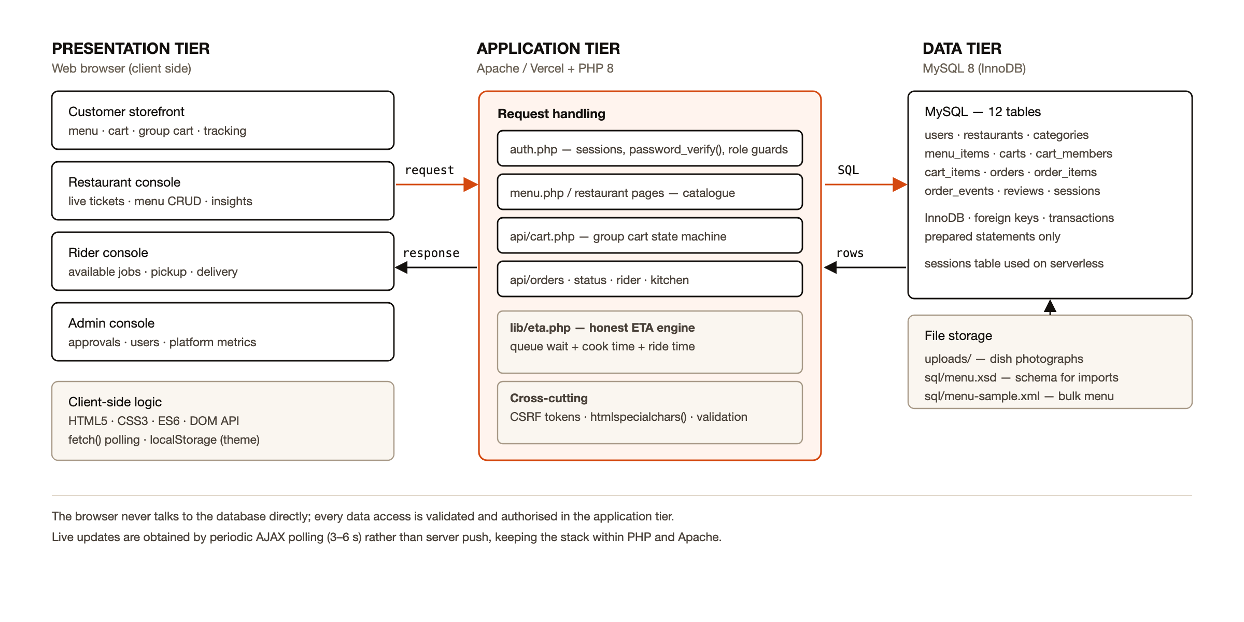
Figure 5.1 — Three-tier architecture of the Fetch system
Two aspects of the architecture deserve comment. First, the application tier is deliberately thin in terms of frameworks but not in terms of responsibility: authentication, role enforcement, price derivation, estimation and all validation live there, because it is the only tier the client cannot modify. Second, there is no separate real-time service. Interfaces that must stay current poll a JSON endpoint on an interval appropriate to the page — three seconds for a shared cart, four for the kitchen board, five for order tracking and six for the busy meters — and pause when the browser tab is hidden.

5.3 System flow
Figure 5.2 traces a single order from the moment a customer opens a menu to the moment the delivery is recorded, showing which actor and which tier is responsible at each step. The flow is presented as four lanes, because the central design claim of the project is that one record is read and written by four different parties.
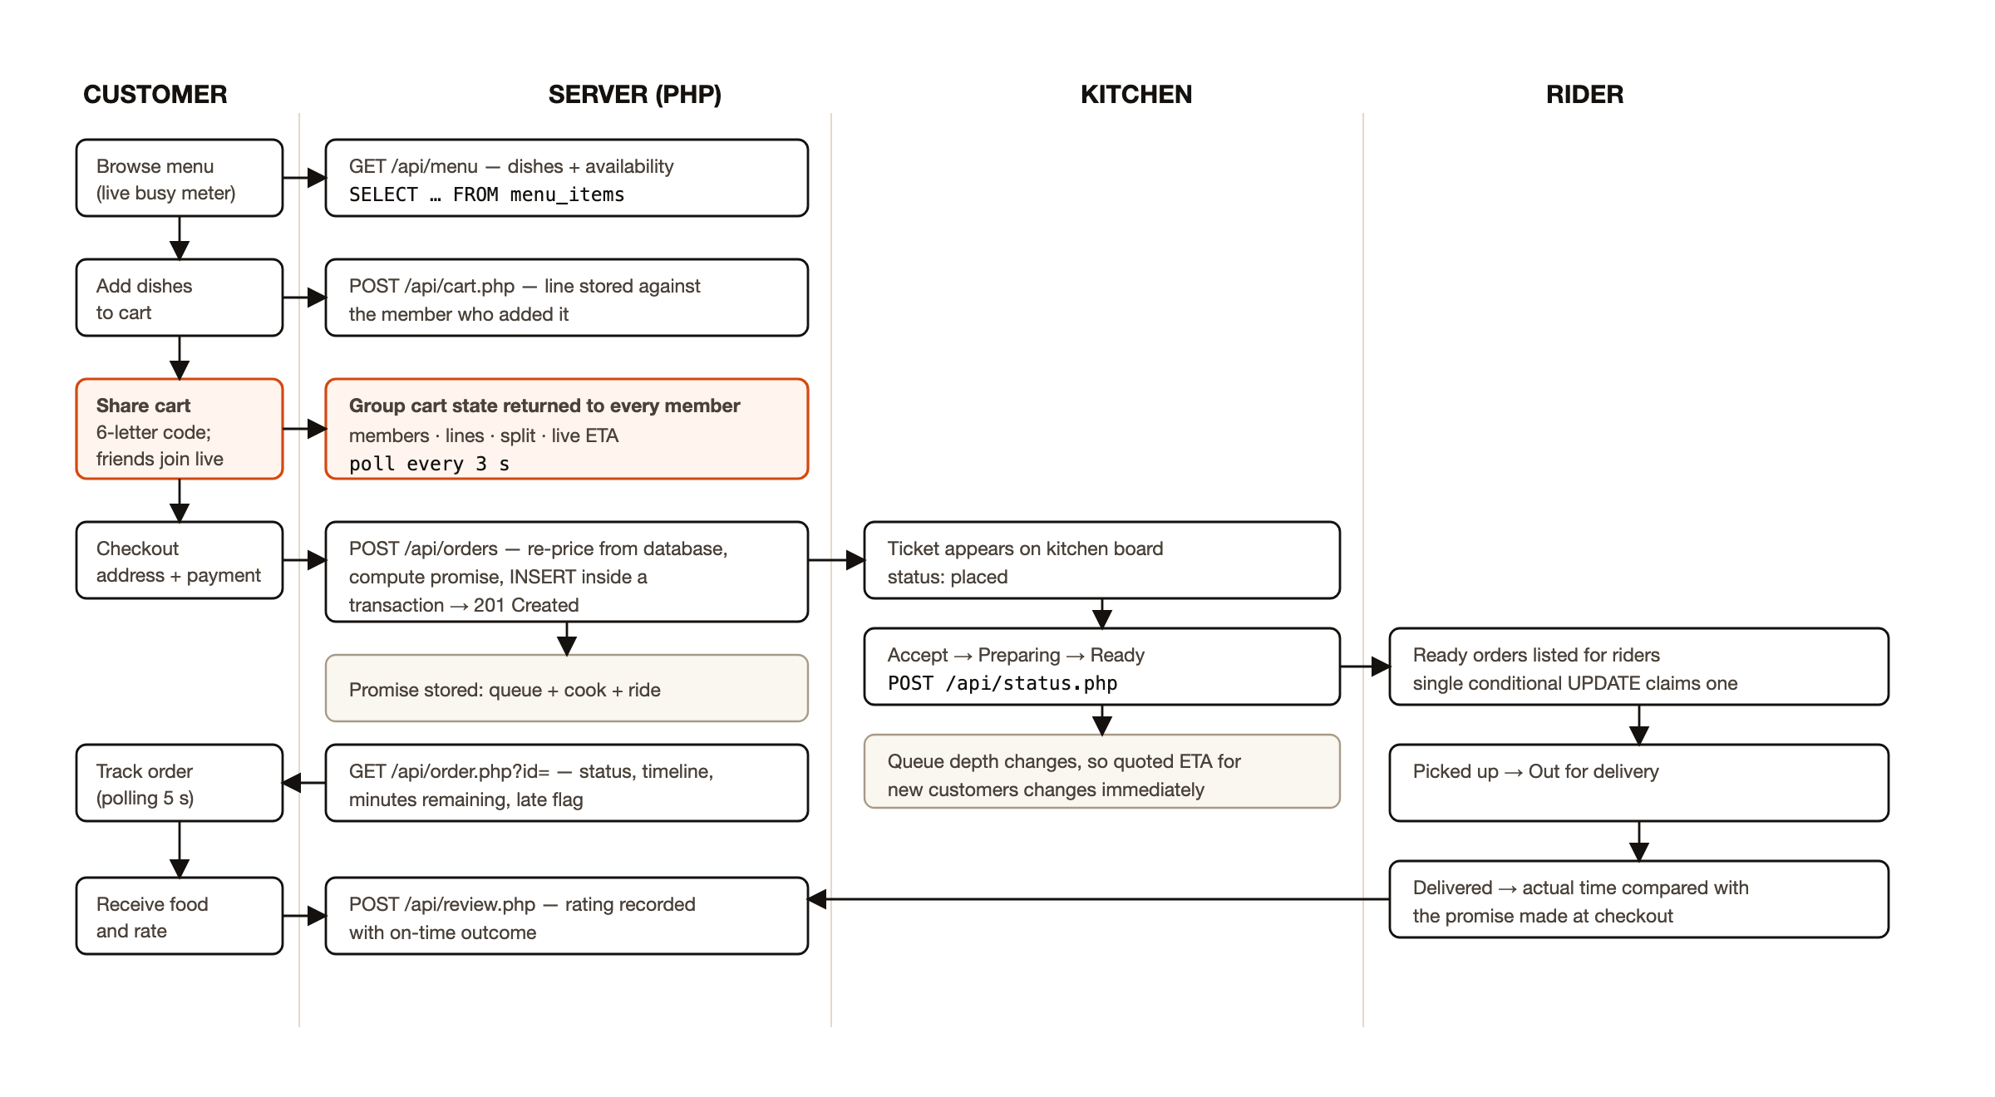
Figure 5.2 — Order lifecycle across customer, server, kitchen and rider
The lifecycle is modelled explicitly as a status enumeration — placed, accepted, preparing, ready, out for delivery, delivered, with cancellation available before dispatch — and transitions are validated on the server. A transition may only move forward, may only be made by the role that owns it, and writes both the new status and a timestamped event row. The event rows are what the customer's timeline renders, which means the timeline cannot drift from the order's actual history.

5.4 Use cases
Figure 5.3 shows the use-case view. Four authenticated roles are supported, together with an unauthenticated guest participant who may join a shared cart and add items but may not check out. The guest is not a convenience: it is the mechanism that makes the shared cart usable in practice, since requiring every friend to register would reintroduce the friction the feature exists to remove.
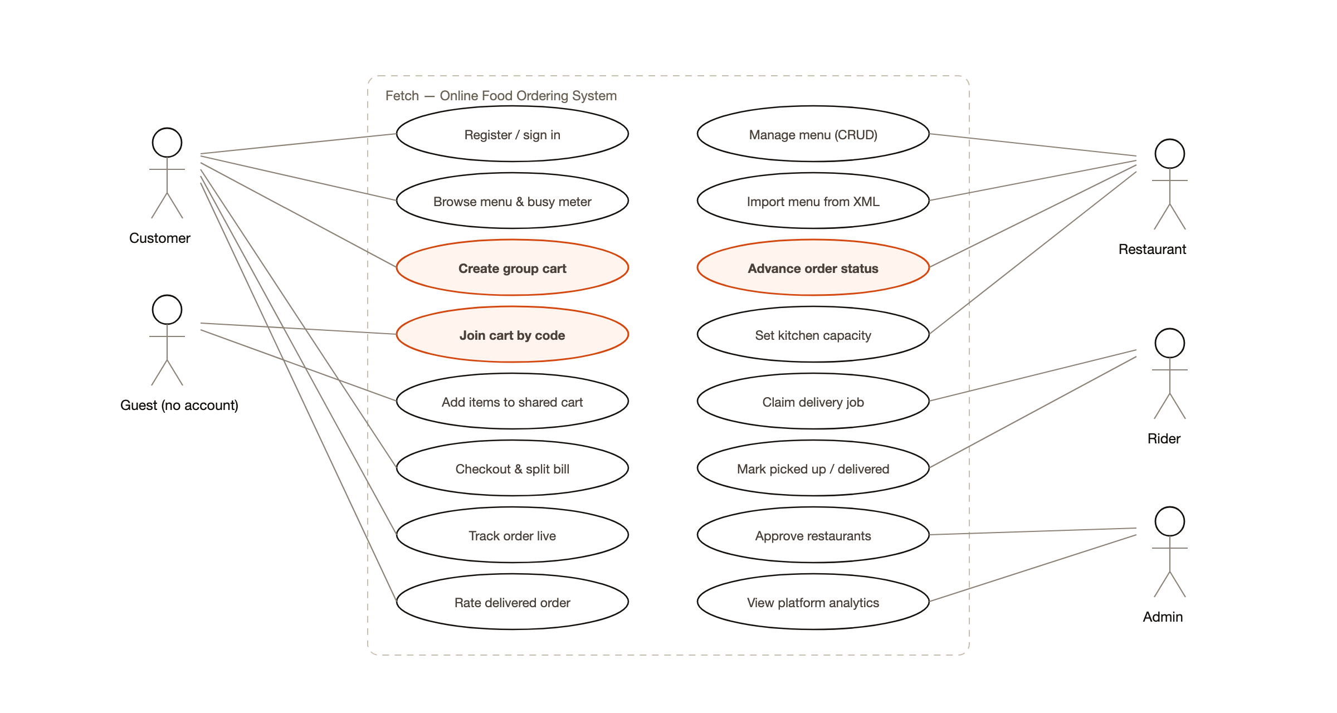
Figure 5.3 — Use-case diagram showing the four roles and the guest participant

5.5 Data flow
Figure 5.4 gives the level-1 data flow diagram. Six processes are identified — catalogue, group cart, ordering, fulfilment, estimation and analytics — along with the six groups of data stores they read and write. The estimator appears as a process rather than as a step inside ordering because it is consulted twice: once while the customer is still deciding, and again at checkout when the promise is fixed.
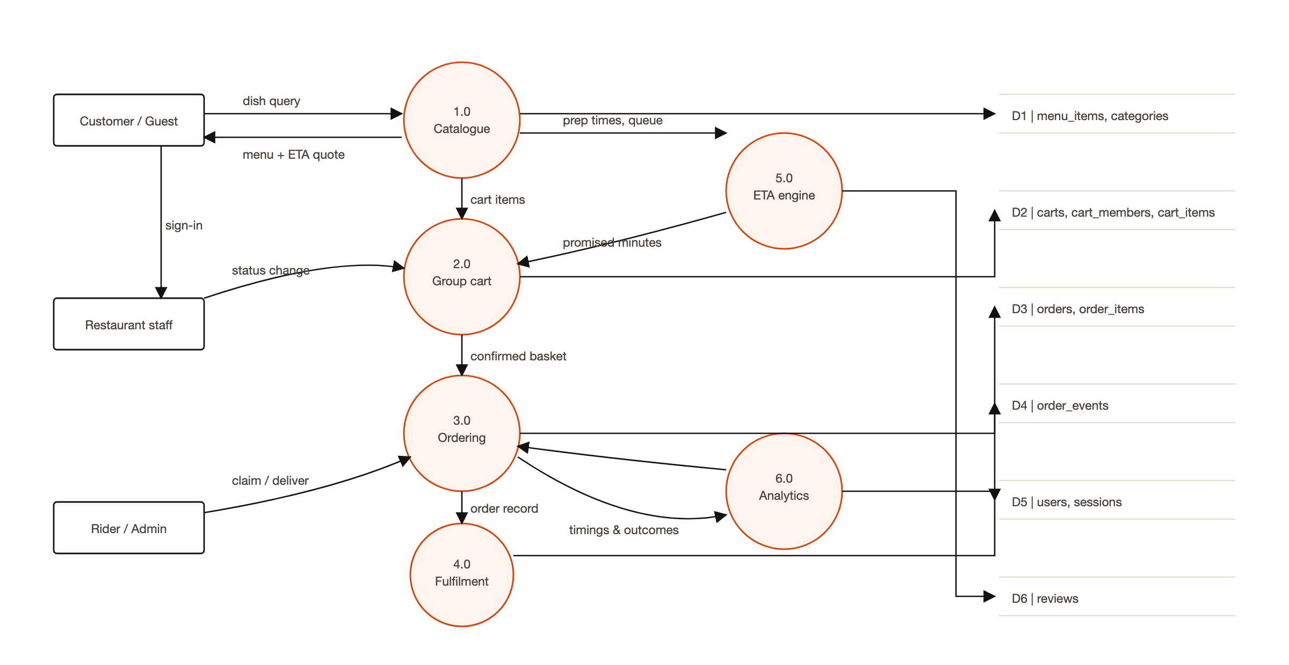
Figure 5.4 — Level-1 data flow diagram

5.6 Database design
The schema comprises twelve tables in InnoDB, with foreign keys declared and enforced. Figure 5.5 shows the entity-relationship diagram, and Table 5.2 summarises the purpose of each table.
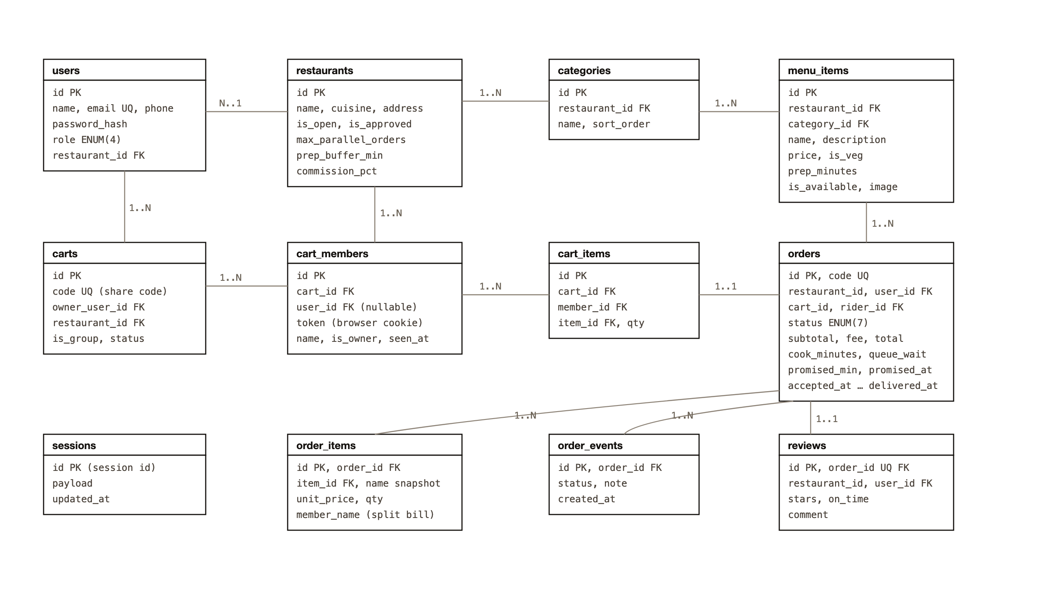
Figure 5.5 — Entity-relationship diagram of the twelve database tables
Three decisions in the schema are worth justifying. The cart is split across three tables — carts, cart_members and cart_items — rather than being a single list, because each line must know which member added it; this is the structural basis of the automatic bill split. Order lines store a snapshot of the dish name and unit price rather than only a foreign key, so that a later change to the menu cannot retroactively alter a historical receipt. And the order row stores the estimate that was quoted at checkout, together with the queue wait and kitchen load at that instant, which is what makes the promise auditable rather than merely displayed.
Table | Purpose
users | Accounts for all four roles, with the password hash and, for restaurant staff, the restaurant they manage
restaurants | Profile, approval and open/closed state, plus the two capacity parameters used by the estimator
categories | Menu sections belonging to a restaurant
menu_items | Dishes with price, dietary marker, availability and preparation time
carts | A cart as an entity: share code, owner, restaurant and status
cart_members | Participants in a cart, identified by account or by browser token
cart_items | Lines in a cart, each attributed to a member
orders | The order, its totals, its status and the promise made at checkout
order_items | Ordered lines with name and price snapshots and the member who chose them
order_events | Timestamped status history, rendered as the customer timeline
reviews | Rating and comment, with whether the order met its promise
sessions | Session storage used when the host provides no persistent filesystem
Table 5.2 — Database tables and their purpose

5.7 The delivery time estimator
The estimator is the algorithmic core of the project and is described here in full. Its inputs are the set of orders the kitchen is still cooking, the preparation times of the dishes concerned, the kitchen's capacity parameters, and the basket being priced. Figure 5.6 shows the stages.
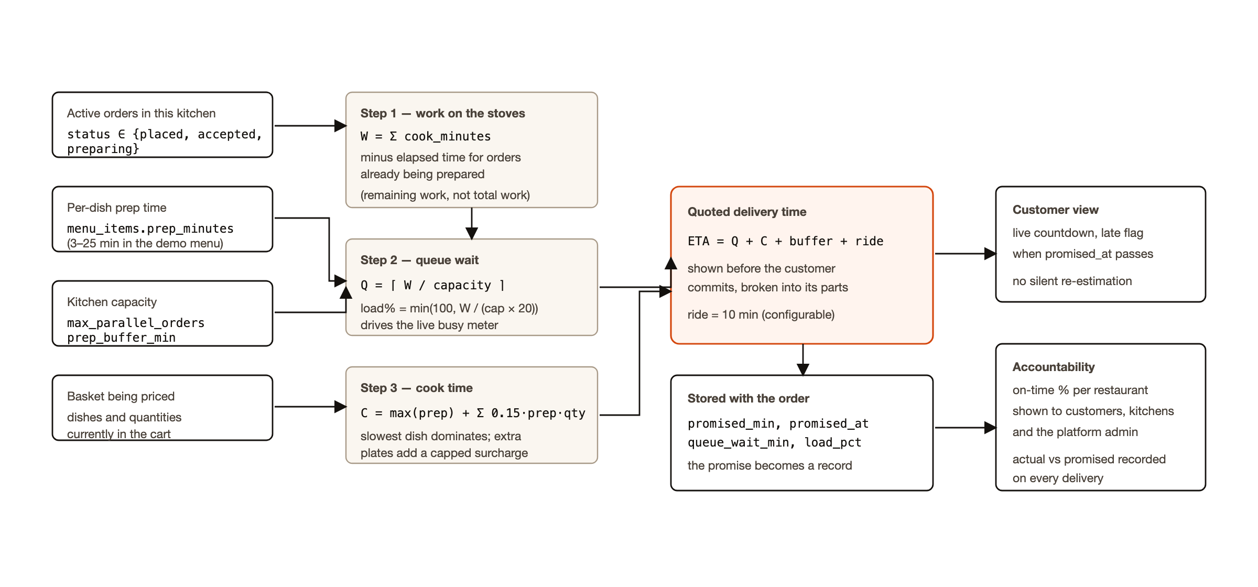
Figure 5.6 — Block diagram of the kitchen-load delivery time estimator
Step one computes the outstanding work. For every order whose status is placed, accepted or preparing, the stored cooking time is taken; for an order already being prepared, the minutes elapsed since it was accepted are subtracted, so that a ticket half-cooked contributes only its remainder. The sum is the backlog W, in minutes of cooking.
Step two converts the backlog into a waiting time. If the kitchen prepares c orders in parallel, the queue wait is Q = ⌈W / c⌉. The same quantity, normalised against a nominal twenty minutes of work per burner, produces the load percentage that drives the busy meter shown on the landing page, and the four descriptive bands — free, steady, busy, slammed — are thresholds on that percentage.
Step three computes the cooking time of the basket itself. Dishes are cooked concurrently, so the dominant term is the slowest dish rather than the sum; each additional plate nevertheless adds a surcharge of fifteen per cent of its own preparation time, capped in total, to reflect that a larger order does occupy the kitchen longer. A per-restaurant plating buffer is added.
The quoted delivery time is therefore ETA = Q + C + buffer + ride, where C is the basket cooking time and ride is the configured travel time. The three principal components are displayed to the customer separately, so that a long estimate is visibly attributable to a busy kitchen rather than to an unexplained number.
// lib/eta.php — the backlog, with partially cooked orders discounted
foreach ($rows as $o) {
$work = (float) $o['cook_minutes'];
if ($o['status'] === 'preparing' && $o['accepted_at']) {
$done = (time() - strtotime($o['accepted_at'])) / 60;
$work = max(0.0, $work - $done); // only what is left
}
$pending += $work;
}
$queueWait = (int) ceil($pending / $capacity);
At checkout the quoted figure is written to the order together with the queue wait and the load percentage at that instant, and an absolute promised time is stored. Everything the system subsequently says about lateness — the customer's countdown, the red flag on a kitchen ticket, the on-time percentage on the insights page and the platform figure in the administrator console — is derived from that single stored promise.

5.8 Tools and technologies
Technology | Role in the system
HTML5 | Semantic document structure; forms with native validation attributes
CSS3 | Custom properties for the design system; Grid and Flexbox layout; media queries; keyframe animation; light and dark themes
JavaScript (ES6) | DOM updates, cart interactions, polling loops, counters and reveal animations; no framework or build step
Fetch API | All asynchronous requests to the JSON endpoints
localStorage | Remembering the chosen theme per browser
XML and XSD | Bulk menu import validated against sql/menu.xsd before any row is written
DOM parser (PHP) | Reading the validated menu document server-side
JSON | Response format of every API endpoint
PHP 8 | Request handling, sessions, authentication, authorisation, validation, file upload, the estimator and all business logic
MySQL 8 / InnoDB | Twelve related tables, prepared statements, foreign keys, transactions and aggregate reporting queries
Apache (XAMPP) | Local web server for development and the laboratory demonstration
Vercel + cloud MySQL | Public deployment; PHP runs as a serverless function with session state in the database
Git and GitHub | Version control and collaboration; the repository is public
Chrome DevTools | Network inspection, responsive testing and performance measurement
Table 5.1 — Tools and technologies used, with their role in the system

6. IMPLEMENTATION
This chapter documents how the design of Chapter 5 was realised. It is organised by module, follows the order in which a request travels through the system, and shows the running interfaces. The complete source is available in the project repository; the extracts reproduced here are those where a design decision is visible in the code.

6.1 Project structure and request handling
The application is a set of PHP pages at the document root with four role-specific directories and one directory of JSON endpoints. A single configuration file is included first by every entry point; it reads configuration from environment variables with local defaults, opens the database connection, starts the session and loads the library modules for authentication, helpers, the estimator, the cart and the page layout.
Path | Contents
config.php | Configuration, environment handling, session bootstrap
lib/ | db.php, auth.php, helpers.php, cart.php, eta.php, session.php, layout.php
api/ | JSON endpoints: cart, load, order, status, kitchen, rider_feed, admin_feed, restaurant
r/ | Restaurant console: kitchen board, orders, menu, XML import, insights, settings
rider/ | Rider console: available deliveries and my deliveries
admin/ | Administrator console: overview, restaurants, orders, users
sql/ | schema.sql, seed.php, menu.xsd, menu-sample.xml
assets/ | app.css (design system and motion layer), app.js (shared client helpers)
Table 6.1 — Module-wise implementation summary

6.2 Authentication, sessions and role enforcement
Registration validates in the browser and again on the server, because client-side validation is a convenience and never a control. Passwords are stored using PHP's password_hash() with the default algorithm and verified with password_verify(); no password is written to a log or returned in a response. On successful authentication the session identifier is regenerated to prevent fixation, and the user is redirected to the landing page appropriate to the role.
Authorisation is enforced by a guard called at the top of every protected page and endpoint. The guard loads the current user, compares the role against those permitted, and redirects or returns 403 otherwise. Because the same function is used by pages and by API endpoints, it is not possible to reach an endpoint by URL that the corresponding page would have refused.
/** Guard a page or endpoint to one or more roles. */
function require_role(string ...$roles): array {
$user = require_login();
if (!in_array($user['role'], $roles, true)) {
http_response_code(403);
redirect(home_for($user['role']));
}
return $user;
}

6.3 Catalogue and the live busy meter
The landing page lists approved restaurants with their rating, price floor and current kitchen load, and the menu page lists dishes grouped by category with their price, dietary marker and preparation time. The busy meter is refreshed by polling a JSON endpoint; the dial is drawn with a CSS conic gradient whose angle is a registered custom property, so a change in load animates smoothly rather than jumping. Figure 6.1 shows the landing page as deployed.
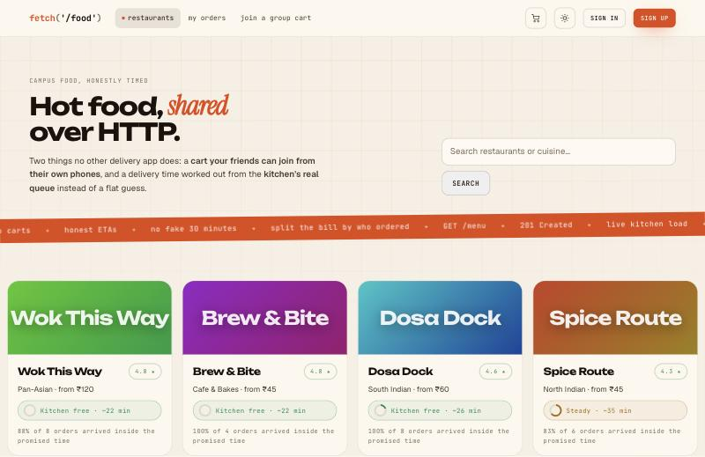
Figure 6.1 — Customer landing page with live kitchen-load meters
An early version of this page issued two queries per restaurant to compute the load, which was invisible on a local server and costly over a network. The queries were consolidated into a single pair of statements covering all restaurants at once, as discussed in Chapter 7.

6.4 The cart and the group cart
The cart is the module in which the central design decision of this project is realised. A cart row records a share code, an owner, a restaurant and a status; a member row records a participant, who may be an authenticated user or a guest identified by a browser token; and an item row records a dish, a quantity and the member who added it. A single-person cart is simply a cart with one member, so there is only one code path to maintain.
Sharing is initiated by the owner, which marks the cart as a group cart and exposes the six-character code and a link. A friend opening the link supplies a display name and is admitted; no account is required. Each open page polls the cart endpoint every three seconds and redraws the member list with presence indicators, the lines with their attributions, the running total, the live estimate and a short activity feed. Figure 6.3 shows two participants in one cart.
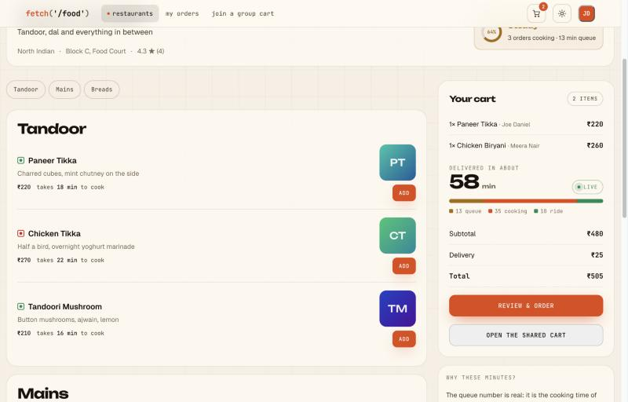
Figure 6.2 — Menu page with the itemised delivery estimate
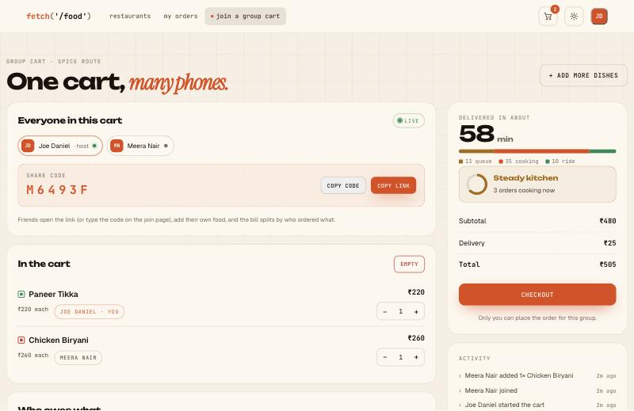
Figure 6.3 — Live group cart with two members and the automatic bill split
Identifying guests proved to be the subtle part. The first implementation held the guest's membership in the PHP session. That worked locally and failed intermittently once deployed, because on a serverless host two concurrent requests may be served by different instances, and the slower one writes the whole session back — so a membership recorded during a join could be erased by a poll that had started before it. Membership was therefore moved to a token stored in a cookie and recorded in the cart_members table, and the cart is located from the database when the session is empty. The session became an optimisation rather than the source of truth.
The division of the bill follows from attribution and requires no separate feature: the cost of each line is charged to the member who added it, and the delivery fee is divided equally among the participants.

6.5 Checkout and the order transaction
Checkout is the point at which client-supplied data stops being trusted. The server re-reads every line from the database, recomputes the subtotal from current prices, verifies that nothing has become unavailable, recomputes the estimate against the kitchen's state at that moment, and writes the order and all of its lines inside a single transaction so that a partially saved order cannot exist. The human-readable order code is generated and checked for uniqueness before insertion.
$pdo->beginTransaction();
try {
// prices re-read from menu_items, never taken from the browser
$eta = eta_breakdown($restaurantId, $lines);
$orderId = insert('INSERT INTO orders (…, promised_min, promised_at) …');
foreach ($lines as $l) { insert('INSERT INTO order_items …'); }
exec_sql("UPDATE carts SET status = 'ordered' WHERE id = ?", [$cart['id']]);
$pdo->commit();
} catch (Throwable $e) { $pdo->rollBack(); }

6.6 Order tracking
The tracking page renders the promise, a timeline built from the stored event rows, the receipt and, for a group order, the amount each participant owes. A polling loop updates the countdown and the status badge, and animates the number rather than replacing it. When the promised moment passes without delivery, the page says so explicitly instead of quietly revising the estimate upward.
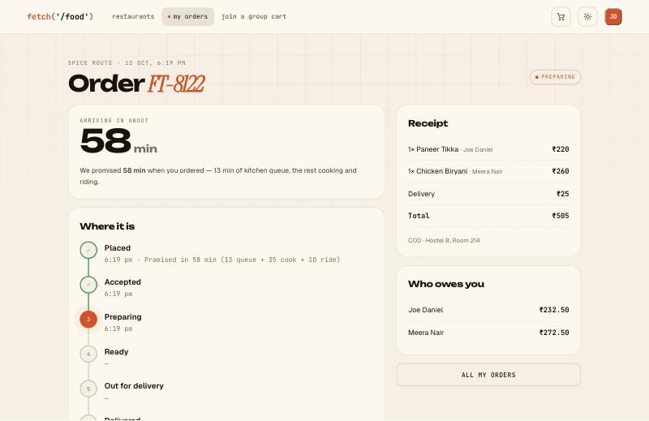
Figure 6.4 — Order tracking page showing the promise and the status timeline

6.7 The restaurant console
The kitchen board shows every live ticket with its items, the member who ordered each item in a group order, the waiting time and the minutes remaining against the promise. One button advances a ticket; late tickets are outlined in red. A toggle closes the restaurant to new orders without hiding its menu. The board polls every four seconds, and the panel is redrawn only when the content has actually changed, so the page does not flicker.
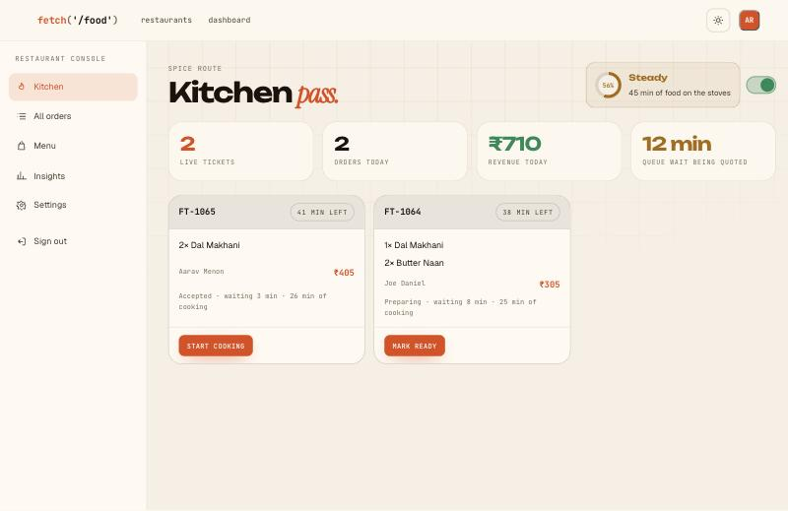
Figure 6.5 — Restaurant kitchen console with live tickets
Menu management provides full create, read, update and delete operations over dishes and sections, with image upload constrained by MIME type and size and with files renamed before storage. The insights page reports revenue by day, the most ordered dishes, recent ratings and — the figure that matters for this project — the proportion of orders that met their promise.
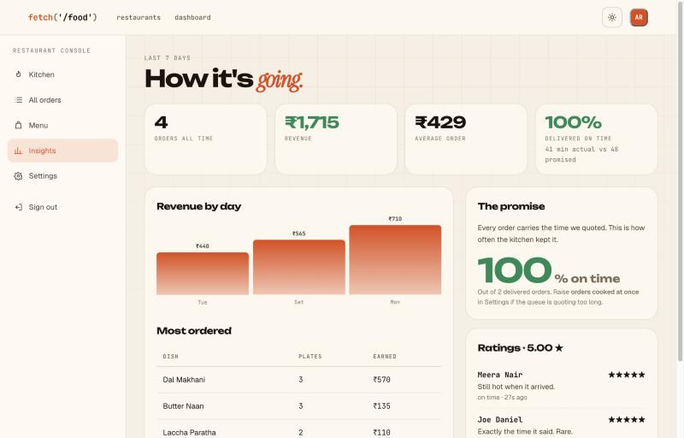
Figure 6.6 — Restaurant insights page reporting promise accuracy

6.8 Bulk menu import with XML and XSD
A restaurant may upload an entire menu as an XML document. The server validates the document against sql/menu.xsd before writing anything; if validation fails, the parser errors are reported with line numbers and no rows are inserted. Only a valid document is walked with the DOM API, and the inserts are wrapped in a transaction. The schema constrains section names, dish names, prices, preparation times and the vegetarian flag, so the gate rejects both malformed documents and semantically implausible values such as a negative price.
$doc = new DOMDocument();
if (!$doc->load($file)) { /* not well-formed */ }
elseif (!$doc->schemaValidate(ROOT_PATH . '/sql/menu.xsd')) {
foreach (libxml_get_errors() as $err) { /* report line numbers */ }
} else {
foreach ($doc->getElementsByTagName('section') as $section) { /* insert */ }
}

6.9 The rider and administrator consoles
The rider console lists orders that are ready and unclaimed. Claiming is implemented as a single conditional update, so that two riders pressing the button at the same instant cannot both acquire the same delivery: the update succeeds for exactly one of them and the other is told that somebody was faster. The administrator console reports platform totals, commission, on-time performance, live kitchen loads and orders in flight, and provides approval and suspension of restaurants together with onboarding of restaurants and riders.
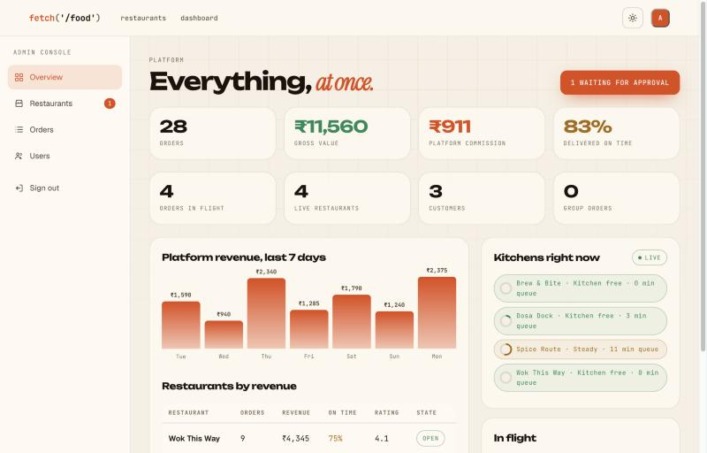
Figure 6.7 — Administrator overview of the platform
$rows = exec_sql(
"UPDATE orders SET rider_id = ?
WHERE id = ? AND rider_id IS NULL AND status = 'ready'",
[$user['id'], $id]);
if (!$rows) { json_out(['error' => 'Another rider got there first.'], 409); }

6.10 API endpoints
Endpoint | Method | Purpose
api/cart.php | POST | Join, add, change quantity, remove, share, leave, read state
api/load.php | GET | Current kitchen load for every approved restaurant
api/order.php | GET | Status, timeline and minutes remaining for one order
api/status.php | POST | Advance an order; validated against role and current status
api/kitchen.php | GET | Live tickets, load and today's totals for one restaurant
api/rider_feed.php | GET | Unclaimed ready orders and the rider's own counts
api/admin_feed.php | GET | Live kitchen loads and in-flight orders for the platform
Table 6.2 — Representative API endpoints

6.11 Dataset
A seeding script creates a reproducible demonstration dataset: five restaurants, one of which awaits approval; twenty-nine dishes across five menus with preparation times from three to twenty-five minutes; eleven accounts covering all four roles; and a week of orders including four in progress so that the kitchen load is non-zero when the system is first opened. Delivered orders are given an actual duration drawn around the promise so that the on-time statistics are populated, with roughly one order in eight deliberately running late. The script may be run again at any time to restore a clean state before a demonstration.

7. RESULTS AND DISCUSSION
This chapter reports what the system does when it is run. The measurements were taken on the deployed copy, with the seeded dataset described in Section 6.11, and are reproducible by running the seeding script and repeating the procedure. Two classes of result are presented: the accuracy of the delivery estimate, which is the central claim of the project, and the responsiveness of the system, which determines whether the live interfaces are usable.

7.1 Promise accuracy
The dataset contained 28 orders, of which 24 had been delivered. Of those 24, twenty arrived within the time promised at checkout, giving an on-time rate of 83%. The mean promised duration was 36 minutes and the mean achieved duration 33 minutes, and the mean absolute difference between the two was 5.7 minutes. Table 7.1 and Figure 7.1 break the figures down by restaurant.
Restaurant | Delivered orders | Mean promised (min) | Mean actual (min) | On time
Dosa Dock | 9 | 33 | 32 | 89%
Wok This Way | 8 | 40 | 39 | 75%
Brew & Bite | 5 | 28 | 24 | 80%
Spice Route | 2 | 48 | 41 | 100%
All restaurants | 24 | 36 | 33 | 83%
Table 7.1 — Promise accuracy by restaurant
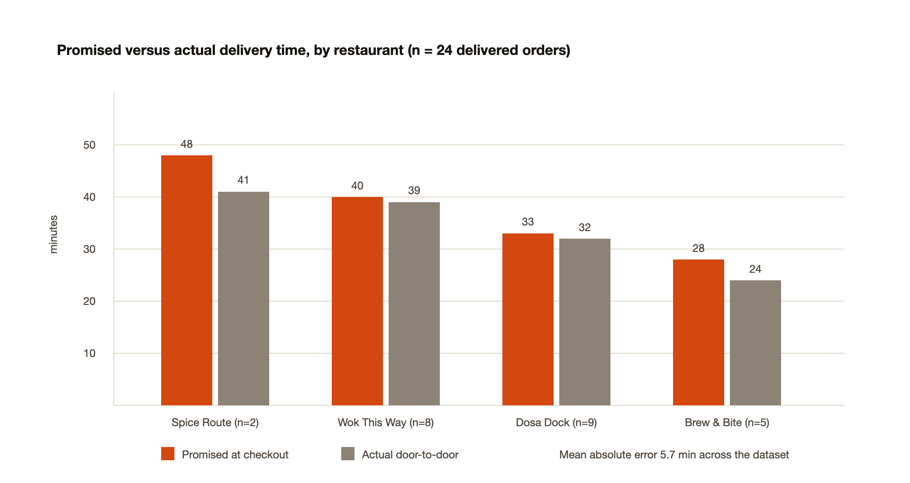
Figure 7.1 — Promised versus actual delivery time by restaurant
Two patterns are visible. First, the estimator is conservative: in every restaurant the mean achieved time is lower than the mean promise, by between one and seven minutes. This is a consequence of the design, which adds a plating buffer and charges a surcharge for additional plates; given a choice between a tight estimate that is often missed and a slightly generous one that is usually met, the project chose the latter deliberately, on the grounds that the purpose of the figure is to be trusted. Second, the restaurants with the longest promises are not the least punctual — Spice Route, whose menu contains the slowest dishes, promised 48 minutes on average and met every promise, whereas Wok This Way promised 40 minutes and met three quarters of them. Punctuality tracks the stability of preparation times rather than their magnitude.
Figure 7.2 shows the distribution of the signed difference between the achieved and promised durations. The distribution is asymmetric by construction: thirteen orders arrived within five minutes early, seven between five and ten minutes early, and four were late, two of them by more than ten minutes.
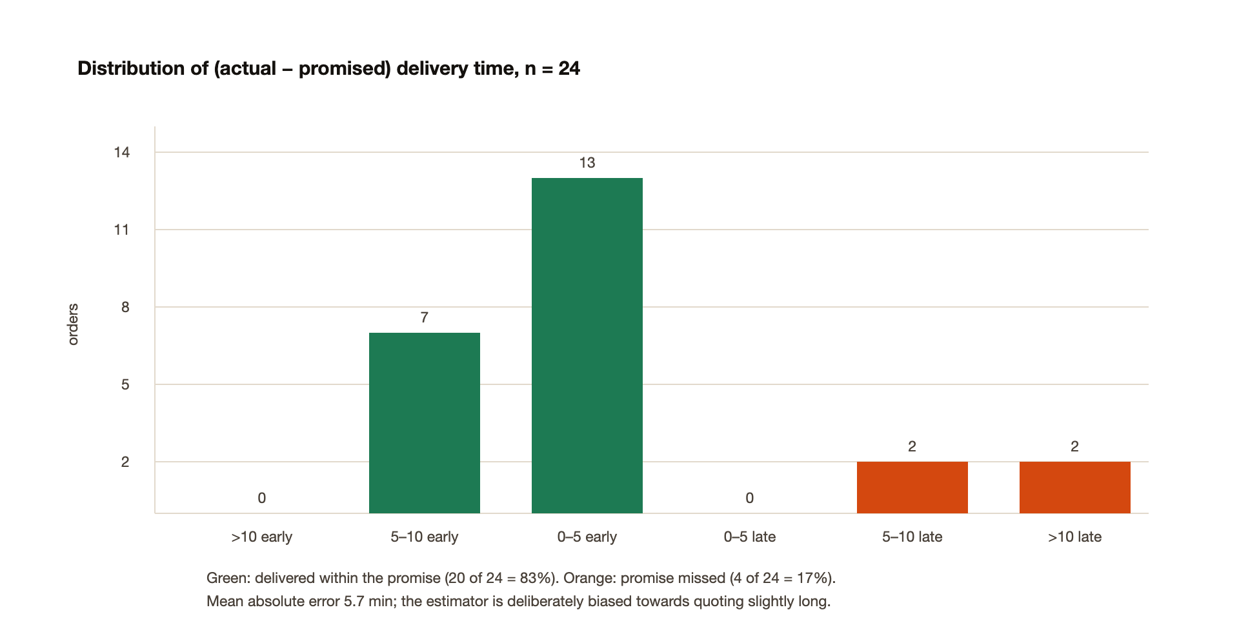
Figure 7.2 — Distribution of the difference between actual and promised time
The late orders are informative. In each case the order was placed when the kitchen was already at a high load, where the queue term dominates the estimate; an error in the queue term is proportionally larger than an error in the cooking term because it aggregates several tickets. A kitchen that forgets to mark a ticket as ready also inflates the backlog for every subsequent customer, which is a dependency on human behaviour that the system cannot design away — although Section 8.3 suggests a mitigation.

7.2 Responsiveness
Response times were measured against the deployed system with the database in a different continent from the application at first, and in the same region afterwards. Table 7.2 and Figure 7.3 summarise the effect of two changes: relocating the serverless function to the database's region, and consolidating the per-restaurant load queries into a single pair of statements.
Request | Before tuning | After tuning
Shared cart refresh (api/cart.php) | 6.4 s | 0.8 s
Landing page with four busy meters | ~6.9 s | 0.5–1.1 s
Menu page with cart sidebar | not measured | 0.9–1.1 s
Load endpoint (api/load.php) | not measured | 0.75 s
First request after an idle period (cold start) | — | 5–7 s
Database queries for the landing page | 2N + 1 (N = restaurants) | 3
Table 7.2 — Measured server response times
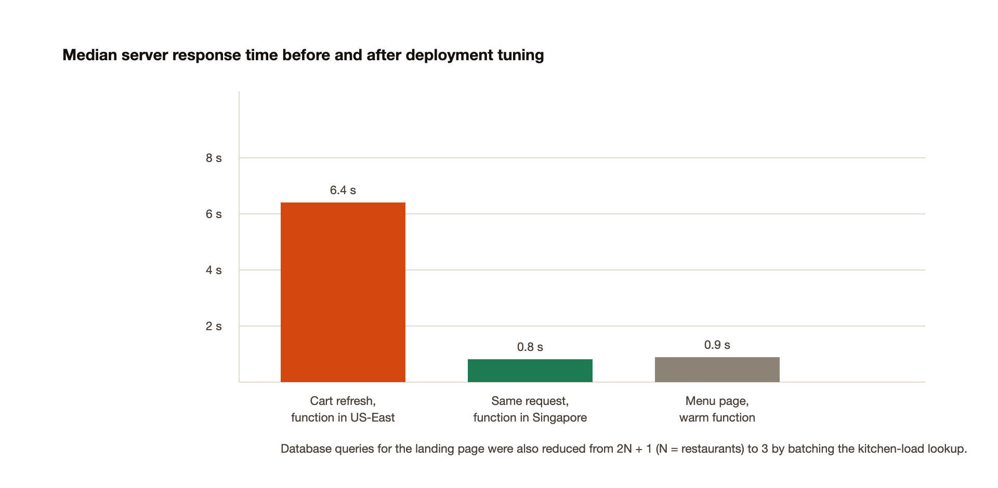
Figure 7.3 — Median server response time before and after deployment tuning
The result worth drawing out is that the dominant cost was neither PHP nor MySQL but geography. With the application in one region and the database in another, every query paid an intercontinental round trip, and a page issuing nine queries paid it nine times. Moving the function beside the database reduced a 6.4-second cart refresh to 0.8 seconds — an improvement of roughly eight times that required no change to a single line of application logic. Reducing the query count then removed most of what remained. Cold starts, which affect only the first request after an idle period, remain a property of the free serverless host rather than of the application.
For the live interfaces, propagation between two devices was observed to be the polling interval plus one round trip: an item added by one participant appeared on the other participant's screen within approximately three to four seconds, which is comfortably inside the limit at which an interface still feels connected to the user's action.

7.3 Functional verification
The complete order lifecycle was exercised on the deployed system across four independent sessions. A customer created a cart and shared it; a guest with no account joined through the link and added an item, which appeared on the host's screen with the correct attribution and an updated split; the host checked out, and the order appeared on the kitchen board with both members named; the kitchen advanced the ticket through accepted, preparing and ready; a rider claimed it, marked it picked up and then delivered; and the customer's tracking page followed each transition and finally compared the achieved duration with the promise. Guest identity was verified to survive the deletion of the session cookie, confirming that the token mechanism described in Section 6.4 behaves as intended.

7.4 Discussion against the objectives
Objective | Outcome
O1 — Replace the unrecorded order | Met. Every order, line and status change is persisted; the timeline is rendered from stored events
O2 — Four roles in one system | Met. Four consoles with guards on every page and endpoint; 403 on cross-role access
O3 — Cart as a shared object | Met. Verified with two independent sessions; guests participate without an account; split computed automatically
O4 — Defensible delivery estimate | Met. 83% on time, mean absolute error 5.7 min, breakdown shown before ordering and audited after delivery
O5 — Live interfaces without reload | Met. Propagation of 3–4 s observed between devices; polling pauses on hidden tabs
O6 — Apply the course technologies | Met. Mapping given in Chapter 6; XML import rejects invalid documents with line numbers
O7 — Safe by default | Met. Hashed passwords, prepared statements throughout, output escaping, CSRF tokens, server-side re-pricing at checkout
Table 7.3 — Objectives stated in Chapter 3 against outcomes achieved
Two qualifications should be stated plainly. The accuracy figures are obtained on seeded data in which the achieved durations are generated around the promise, so they demonstrate that the estimator, the storage of the promise and the measurement pipeline are internally consistent; they do not constitute validation against a real kitchen, which would require a restaurant willing to expose its operations. And the on-time percentage is sensitive to the sample, since two restaurants contributed fewer than six delivered orders each.

8. CONCLUSION AND FUTURE SCOPE

8.1 Summary
This project set out to replace an unrecorded, opaque ordering process with a system in which the order is a record that four parties read, and to address two shortcomings that persist in existing platforms. Both were addressed by modelling rather than by interface work. Treating the cart as an entity with members, instead of as a property of one user, made simultaneous group ordering and automatic bill division fall out of the data model. Treating the kitchen as a queue, instead of as an unknown, made the delivery estimate explainable, auditable and — on the dataset measured — correct for 83% of deliveries with a mean absolute error of under six minutes. The system was built entirely with the technologies taught in the Web Technologies course, deployed publicly, and exercised end to end across all four roles.

8.2 Learning outcomes
- Server-side validation is not a duplicate of client-side validation. Re-deriving prices at checkout, rather than trusting the browser, is the difference between a form and a system.
- A feature is often a consequence of a schema. The split bill required no dedicated module once lines were attributed to members, whereas no amount of interface work would have produced it from a single-owner cart.
- Assumptions that hold on localhost can fail in deployment. File-based sessions, a filesystem that accepts uploads, and a database on the same machine are three such assumptions, and each had to be replaced after deployment rather than before.
- Measurement changes design. Storing the promise made the project able to report its own failures, and the resulting figure — including the late orders — is more persuasive than an unverifiable claim of accuracy.
- Latency is frequently architectural rather than algorithmic. An eightfold improvement came from moving the application next to its database, not from optimising code.
- Live interfaces built on polling are sufficient for this class of problem, provided updates are applied only when the data has actually changed and polling stops when the tab is hidden.

8.3 Future scope
- Replace polling with server push. WebSockets or server-sent events would reduce propagation from seconds to milliseconds and remove redundant requests, at the cost of leaving the plain PHP and Apache stack the course prescribes.
- Learn the preparation times instead of accepting them. The system already records, for every ticket, the time between acceptance and readiness. Those timings could update each dish's preparation time automatically, so that the estimator improves as the restaurant is used and is no longer dependent on the accuracy of the restaurant's own estimates.
- Model travel time properly. Replacing the constant with a distance- or zone-based figure, and ultimately with a routing service, would address the component of the estimate that is currently least justified.
- Settle the split bill inside the application. The system computes what each participant owes but does not move money; integrating a payment gateway with per-participant collection would complete the group ordering feature.
- Detect stale tickets. A ticket left in the preparing state inflates the backlog for every subsequent customer. Flagging tickets that have exceeded their expected cooking time by a wide margin, and prompting the kitchen, would protect the estimate from human error.
- Scheduled and pre-ordered collection. Allowing an order to be placed for a specified later slot, with the kitchen seeing batched demand per slot, would serve the campus break-time case that motivated the project.
- Accessibility and localisation audit. A formal pass against WCAG, together with translation of the interface, would widen the usable audience beyond the present English, mouse-and-touch assumption.

REFERENCES
[1] WHATWG, "HTML Living Standard," Web Hypertext Application Technology Working Group. [Online]. Available: https://html.spec.whatwg.org/. [Accessed: Oct. 2026].
[2] W3C, "CSS Snapshot 2023," World Wide Web Consortium, W3C Group Note, 2023. [Online]. Available: https://www.w3.org/TR/css-2023/. [Accessed: Oct. 2026].
[3] Ecma International, "ECMA-262: ECMAScript Language Specification," 14th ed., Geneva, Switzerland, 2023.
[4] W3C, "Document Object Model (DOM) Level 3 Core Specification," World Wide Web Consortium Recommendation, 2004.
[5] WHATWG, "Fetch Living Standard." [Online]. Available: https://fetch.spec.whatwg.org/. [Accessed: Oct. 2026].
[6] R. Fielding, M. Nottingham, and J. Reschke, "HTTP Semantics," RFC 9110, Internet Engineering Task Force, Jun. 2022.
[7] A. Barth, "HTTP State Management Mechanism," RFC 6265, Internet Engineering Task Force, Apr. 2011.
[8] R. T. Fielding, "Architectural Styles and the Design of Network-based Software Architectures," Ph.D. dissertation, Univ. of California, Irvine, CA, USA, 2000.
[9] W3C, "XML Schema Part 0: Primer Second Edition," World Wide Web Consortium Recommendation, Oct. 2004.
[10] W3C, "Extensible Markup Language (XML) 1.0," 5th ed., World Wide Web Consortium Recommendation, Nov. 2008.
[11] The PHP Group, "PHP Manual: Password Hashing and PDO Prepared Statements." [Online]. Available: https://www.php.net/manual/. [Accessed: Oct. 2026].
[12] Oracle Corporation, "MySQL 8.0 Reference Manual: InnoDB and Transactional Model." [Online]. Available: https://dev.mysql.com/doc/refman/8.0/en/. [Accessed: Oct. 2026].
[13] E. F. Codd, "A Relational Model of Data for Large Shared Data Banks," Communications of the ACM, vol. 13, no. 6, pp. 377–387, Jun. 1970.
[14] P. P. Chen, "The Entity-Relationship Model — Toward a Unified View of Data," ACM Transactions on Database Systems, vol. 1, no. 1, pp. 9–36, Mar. 1976.
[15] OWASP Foundation, "OWASP Top 10:2021 — Web Application Security Risks." [Online]. Available: https://owasp.org/Top10/. [Accessed: Oct. 2026].
[16] OWASP Foundation, "Cross-Site Request Forgery Prevention Cheat Sheet," OWASP Cheat Sheet Series. [Online]. Available: https://cheatsheetseries.owasp.org/. [Accessed: Oct. 2026].
[17] L. Welling and L. Thomson, PHP and MySQL Web Development, 5th ed. Boston, MA, USA: Addison-Wesley, 2017.
[18] R. Nixon, Learning PHP, MySQL & JavaScript, 6th ed. Sebastopol, CA, USA: O'Reilly Media, 2021.
[19] J. Nielsen, "Response Times: The 3 Important Limits," Nielsen Norman Group, 1993. [Online]. Available: https://www.nngroup.com/articles/response-times-3-important-limits/. [Accessed: Oct. 2026].
[20] D. G. Kendall, "Stochastic Processes Occurring in the Theory of Queues and their Analysis by the Method of the Imbedded Markov Chain," The Annals of Mathematical Statistics, vol. 24, no. 3, pp. 338–354, 1953.
[21] DoorDash Inc., "Group Orders," DoorDash Help Centre. [Online]. Available: https://help.doordash.com/. [Accessed: Oct. 2026].
[22] Uber Technologies Inc., "Create a group order," Uber Eats Help. [Online]. Available: https://help.uber.com/ubereats/. [Accessed: Oct. 2026].
[23] Zomato Ltd., "Group Ordering," Zomato Help Centre. [Online]. Available: https://www.zomato.com/. [Accessed: Oct. 2026].
[24] Mozilla Foundation, "MDN Web Docs: Using the Fetch API." [Online]. Available: https://developer.mozilla.org/en-US/docs/Web/API/Fetch_API/. [Accessed: Oct. 2026].

